Buy an Energy Star Heat Pump Water Heater and get a rebate!
Buy a qualified Energy Star Heat Pump Water Heater and get a $300 rebate from Atlantic Municipal Utilities.
Customers may only receive one rebate per piece of qualifying equipment. This offer
is available to customers of Atlantic Municipal Utilities.
Equipment must be installed in facilities that are served electrically by Atlantic Municipal Utilities. Utility representatives may conduct an inspection to survey any installed equipment.

Apply for your Rebate…it’s easy!
- Purchase and take delivery of a qualified product.
- Complete this rebate application form.
- Email the completed form to rebate@AMU1.net, or mail it to Atlantic Municipal Utilities. Include a completed form and a copy of your dated sales receipt.

This rebate offer is good for the purchase of a qualified product listed at left. Restrictions apply as noted. This offer is available to customers of Atlantic Municipal Utilities. Customers may only receive one incentive per piece of qualifying equipment. To receive your rebate, please fill out this form completely with a copy of your sales receipt and email it to rebate@AMU1.net or mail it to:
Atlantic Municipal Utilities
PO Box 517
Atlantic, IA 50022
Incomplete information will delay or disqualify your rebate. Rebate applications must be postmarked within 30 days of purchase.
This rebate program is reviewed and authorized each year for incentives that are available from January 1 through December 31.

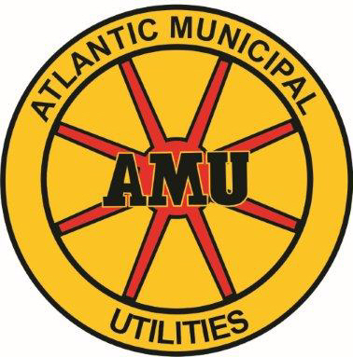
Atlantic Municipal Utilities
Water Heater
Rebate Form
TO BE COMPLETED BY PURCHASER (Required for processing)
To receive your rebate, please fill out this form completely. Email the completed form to rebate@AMU1.net, or mail it to Atlantic Municipal Utilities with a copy of your sales receipt and Energy Star Label. Incomplete information will delay or disqualify your rebate.
Customer Last Name First Name Phone

Street Address City State Zip

Mailing Address (if different) City State Zip

Email Address

Dealer Name Dealer Contact Dealer Phone

The Energy Star product I purchased is a:
- Heat Pump Water Heater

_____________________________________________________________
Brand Name Model Serial #

_____________________________________________________________
Size (gallons) Energy Factor (if known) Install Date

_____________________________________________________________
Utility Account Number

Install Date: ________________________ Date of Purchase: _____________________

Signature: ______________________________________ Date: ________________

Program Details

This program is available to any AMU customer who purchases and installs an Energy Star Electric Heat Pump Water Heater(s) and installs and uses them at Residential or Small Commercial locations serviced by Atlantic Municipal Utilities. Electric Heat Pump Water Heaters are eligible for a $300.00 rebate.
All information requested on this Application form must be provided, including copies of all invoices related to the installation and copies of Energy Star Labels. Rebates will not be provided without proper documentation.
All rebates are subject to verification of installation by an AMU employee. AMU reserves the right to discontinue this program at any time, without notice, and to make minor changes to the program requirements from time to time, as deemed necessary to clarify or improve the program.
All rebates will be applied as a credit to the customer’s account.

Atlantic Municipal Utilities Use Only
Date Received: | Date Inspected: |  | Customer Rate Code:
Electric Heat Pump Water Heater:

No of Units:___________ x $300.00 = $________ rebate
Total Rebate: $ | Date Applied: | Date Rate Changed:

