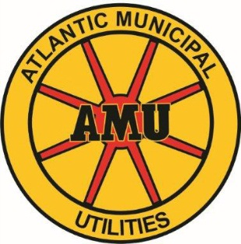

PRE-AUTHORIZED CREDIT CARD PAYMENT AGREEMENT
I hereby authorize Atlantic Municipal Utilities to initiate entries to the below credit card for the payment of services. This authority will remain in effect until I notify Atlantic Municipal Utilities in writing. Notification must be made in such time as to afford Atlantic Municipal Utilities a reasonable time to act on it.

Name: _____________________________________________________
(Please print as it appears on AMU Statement)
AMU Account #: _____________________________________________
(Please use a separate form for each account)
Social Security #: __________________________ Zip Code: ______________
Home Phone #: ( )__________________ Work Phone #: ( ) ______________
Select One: Visa _____ MasterCard ______ Discover ______
Credit Card #: ____________________________ Expiration Date: __________
Cardholder Name: _______________________________________________

Authorized Signature: ____________________________________________
Effective Date: __________________________________________________

