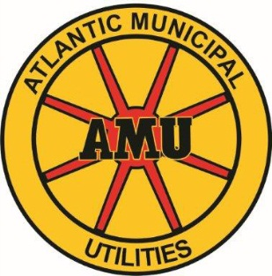
AUTHORIZATION AGREEMENT FOR DIRECT PAYMENT
With AMU’s convenient, free Bank Draft service, your utility payment is automatically deducted from your checking or savings account. You will still receive a monthly statement from AMU showing the current charges and the previous month’s payment reflected on your balance.
Fill out this form and mail to Atlantic Municipal Utilities, P.O. Box 517, Atlantic, Iowa, 50022; or drop it off in our business office at 15 W. 3rd St. Please allow two weeks for processing.
Please fill out the following information as it appears on your bill.
PLEASE SUBMIT THE FORM WITH A VOIDED CHECK.
Name: _____________________________________________________

Service Address: ____________________________________________________
City, State, Zip
Mailing Address: ____________________________________________________
City, State, Zip
Home Phone #: ( ) __________________ Work Phone #: ( ) ______________
AMU Account #: _____________________________________________
(Please use a separate form for each account)
Name of the Bank: ___________________________________________
Routing Number: ____________________________________________
Account Number: ____________________________________________
I hereby authorize Atlantic Municipal Utilities to initiate deduction from my financial institution and authorize the transfer of payment in the amount showing as Amount Due on my monthly bill. This authority is to remain in full force and effect until Atlantic Municipal Utilities has received written notification from me of its termination in such time & manner as to afford Atlantic Municipal Utilities & the my financial institution a reasonable opportunity to act on it.
Authorized Signature: ____________________________________________
Effective Date: __________________________________________________

